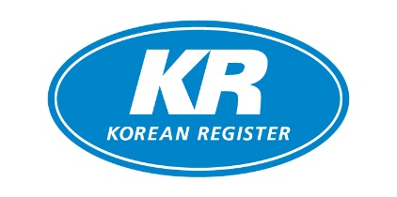

Company Name
Applicant Name
Telephone
E-mail
Remarks

Invoice/Billing address | Shipping address

Item | Price | Q’ty |  | Item | Price | Q’ty
USB | 1,500 USD |  |  | Install | 1,000 USD
Item | Price | Q’ty | ID(s) |  | PW (non-mandatory)
WEB/APP ID | 1,000 USD
* Existing customers are entitled to a 70% discount on the USB version and a 60% discount on the ID/Install versions.
** Wire transfer only for payment method.

KR-CON Price Policy
1. USB version | 2. ID version
$1,500 per 1 copy  Volume discounts  -20~50 units: 10% off  -51~100 units: 20% off  -101 units~: 30% off | $1,000 per 1 ID (Valid for a year)  - 2 IDs: 10% off  - 3 IDs: 20% off  - 4 IDs: 30% off  - KR-CON Web version (http://krcon.krs.co.kr)  - KR-CON App version (iOS & Android)
3. INSTALL version  $1,000 per 1 copy (Valid for a year)  Volume discounts  -20~50 units: 10% off  -51~100 units: 20% off  -101 units~: 30% off  -Can be used in an offline environment after initial download & installation (http://krcon.krs.co.kr) | 4. Special Discounts for Existing Customers  Customers who have previously purchased KR-CON are eligible for the following renewal rates:  USB Version: 70% discount from the standard price.  Web ID & INSTALL Version: 60% discount from the standard price.
How to purchase KR-CON
- Fill out this order form and send it back to krcon@krs.co.kr or fax.
- We will reply with your pro-forma invoice
- Please forward your remittance for the dues to the banking information on the invoice.
- Upon our receipt of your remittance,
- USB unit(s) will be sent by DHL
- Subscription will become valid for your Web/App ID
- Activation code for Install version will be sent via e-mail

Feel free to contact us for more details.

Contact Info.

Convention & Legislation Service Team
Korean Register
Tel: +82 70 8799 8336
Email: krcon@krs.co.kr

